**FACTS Tuition Management**

**Please go to the following website to enroll: https://factsmgt.com/**



**Create new account (below picture)**



**Begin** **enrollment process – Search for Institution using zip code – 45879**

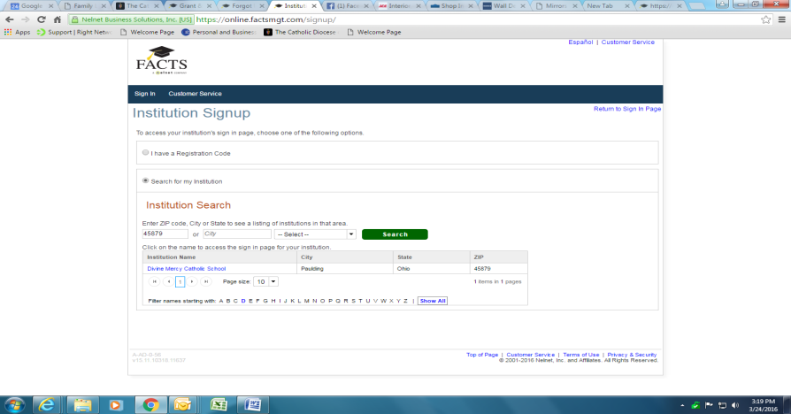

**Choose Divine Mercy School - (click on blue link)**

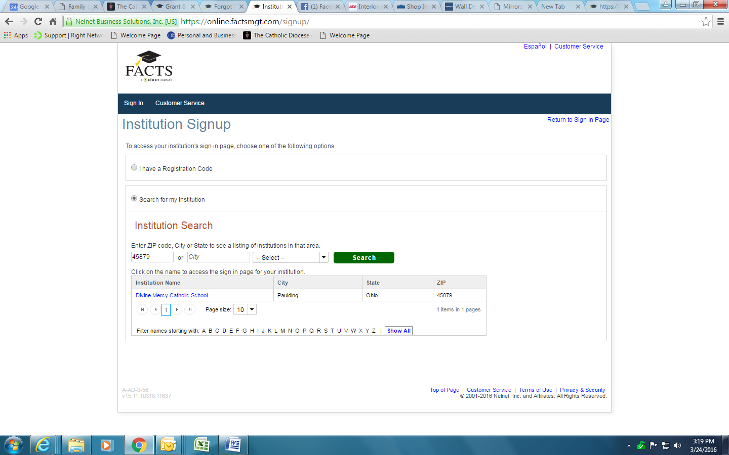

**Choose new account - Create user name and password**

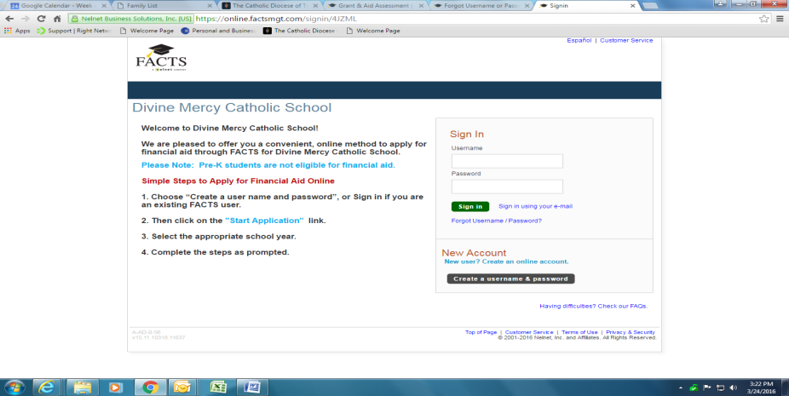

**Add email address to create account**

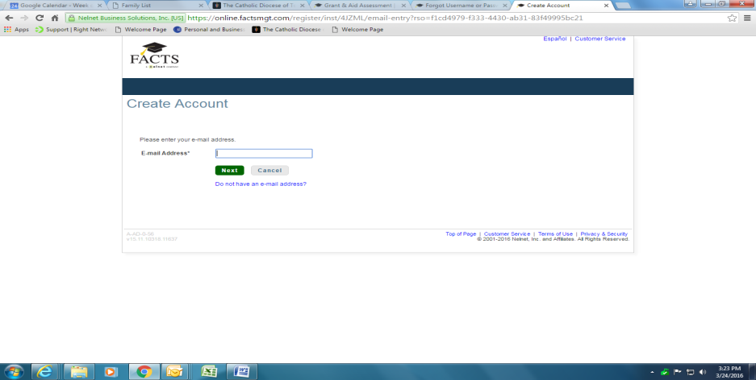

**Create account – input contact information**

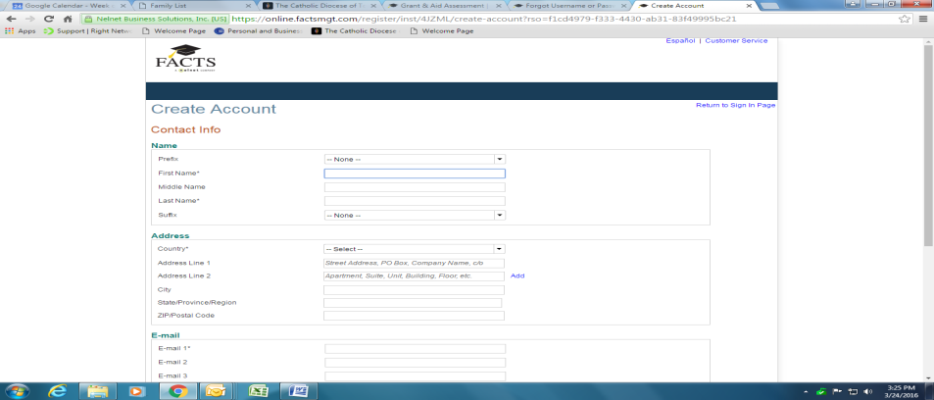

**Create account profile - user name and password**

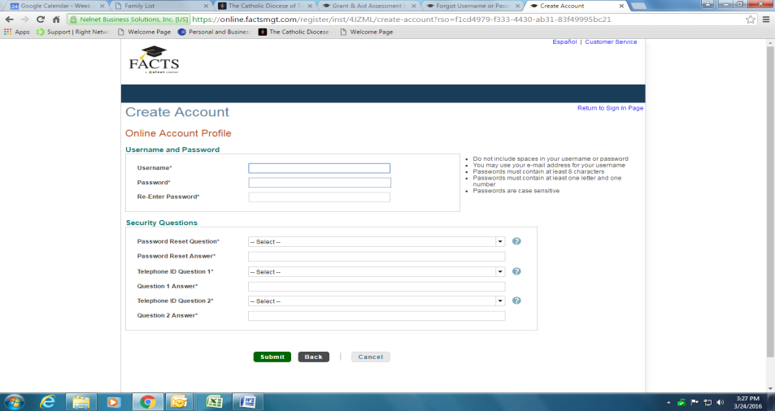

**Payment and billing information**

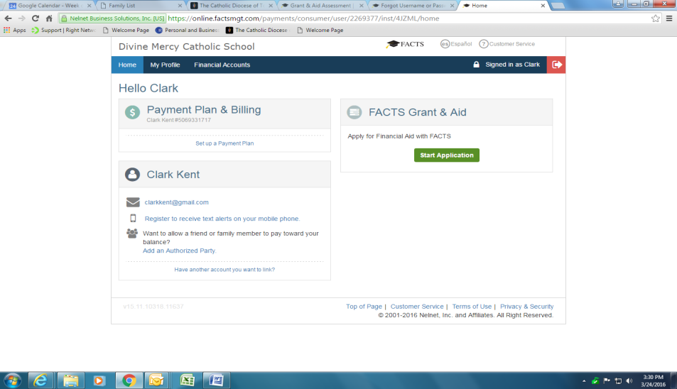

**FACTS Tuition Assistance**

**Please go to the following website to enroll: https://factsmgt.com/services/grant-aid-assessment**



**Create user name and password – (if already set up for Tuition Management -access using this log in and password)**

* **Fee of $29 due at registration**



**Complete enrollment process**