Divine Mercy School
December 9, 2015
Dear Parents,

The students and staff of Divine Mercy School extend their prayers, thoughts and deepest sympathy to Bob Franklin and his family on the recent death of their loved one. Helen was an amazing lady and will be greatly missed.

The e will be a 2-hr professional development delay this Friday, December 11th. Students will not need to be at school before 10:40. The bookmobile will also be spending the day. All students from preschool to sixth grade have a chance to visit the bookmobile and check out books. We are thankful for this opportunity.

Wednesday, Dec. 16 – Cookies for the cookie walk may be brought to school during school hours. The Wednesday Envelope will be sent home on Friday, December 18th.

Thursday, Dec. 17 – Cookies for the cookie walk need to be here no later than 10:00. Since we have “new” hours this year, the cookie walk will begin immediately following the first performance at 1:30 and run till 6:30 before the second performance starts.

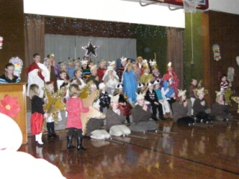The best Christmas show ever will be in the Payne parish hall. We are encouraging anyone that can come to the 1:30 performance to do so. This will help with the crowding at the evening show. Please remember there will be no “saving seats” this year.

The school will open at 6:40 p.m. for the students to come in and get ready for their program. Following the program all students will need to return to the school with their teacher and may be picked up by parents from the classroom.

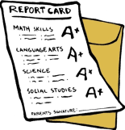Friday, Dec. 18 - Grade cards will go home in the weekly envelope. Students will enjoy a pizza lunch sponsored by the PTA. There will be no lunches from Payne Elementary. School will be dismissed at 2:15!

Respectfully in Christ,
Divine Mercy School Staff

