

Divine Mercy School

October 21, 2015

Dear Parents,

The students and staff of Divine Mercy School extend their prayers, thoughts and deepest sympathy to Jack and Claire Schweller and their family on the recent loss of their loved one. May He continue to grant strength through this most difficult time.

**Field trip Friday, October 23rd –** The Ohio Child Passenger Law states that any child under the age of 8 years old must travel in a booster seat. They will not be allowed to travel in a car unless they have met these requirements. This law mainly affects kindergarten and first grade students**. Please remember to send in a booster seat this Friday for our nursing home field trip.**  Students younger than 12 years will not be allowed to ride in the front seat of a vehicle. All students are required to wear seat belts. Thank you for your cooperation.

**Honoring All Who Served – Veteran’s Day!** We are planning a special Veteran’s Day Mass on Wednesday, November 11th, at 11:00 in the Payne Divine Mercy Church. Immediately following the Mass, students will present a short Veteran’s Day program in the parish hall. Veterans are also invited to be our guest for lunch which will be served at the conclusion of the program. Chicken & noodles, mashed potatoes, green beans and a dinner roll will be served. Please let us know of any guests that will be joining us so we can give a count to the Payne cafeteria. Fill out the enclosed form and return it to school with your student.



The Payne Fire Department visited Divine Mercy School today to talk about fire prevention and fire safety. They demonstrated how a fireman would look dressed in his equipment. We learned not to be scared and to yell or make noise in a smoke filled environment so that the fireman can locate us. We appreciate our fireman’s dedication to protecting us. Remember to discuss fire safety at home and to designate a meeting place if the family would ever need to evacuate.

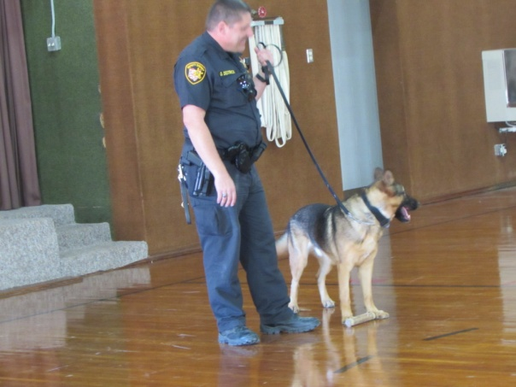

As part of Red Ribbon Week, Gary Deitrick, from the Paulding County Sheriff’s Department, and his dog Jano, presented a program to the students on Monday. He explained the training and the services that his dog provides to the citizens in not only Paulding County but also the surrounding counties. Thank you to Mr. Deitrick for his very informative talk and to Jano for his demonstration of seeking out drugs.

The fever, sore throat, headache and cough “bug” has hit early this school year. **Please remember that your child needs to be fever free, without the aid of any fever reducing medicine, for 24 hours before they return to school.**

Remember there will be **no school** on Thursday and Friday, October 29th and 3oth. Wayne Trace will be conducting their Parent Teacher Conferences on those days. Since we follow their calendar, we will also not be having school even though our conferences aren’t until November

Enclosed in Today’s Envelope

you will find :

* Report cards

Respectfully in Christ,

Divine Mercy School Staff